**6b)Aim: Create an android app to illustrate a progress bar.**

**activity_main.xml**

<RelativeLayout xmlns:android="http://schemas.android.com/apk/res/android"

xmlns:tools="http://schemas.android.com/tools"

android:layout_width="match_parent"

android:layout_height="match_parent"

tools:context=".MainActivity">

<ProgressBar

android:id="@+id/simpleProgressBar"

android:layout_width="wrap_content"

android:layout_height="wrap_content"

android:layout_centerHorizontal="true"/>

<Button

android:id="@+id/startButton"

android:layout_width="200dp"

android:layout_height="wrap_content"

android:text="Start"/>

</RelativeLayout>

**MainActivity.java**

package example.gb.progressbarexample;

import android.support.v7.app.AppCompatActivity;

import android.os.Bundle;

import android.view.Menu;

import android.view.MenuItem;import android.view.View;

import android.widget.ProgressBar;

import android.widget.Button;

public class MainActivity extends AppCompatActivity {

@Override

protected void onCreate(Bundle savedInstanceState) {

super.onCreate(savedInstanceState);

setContentView(R.layout.activity_main);

final ProgressBar simpleProgressBar = (ProgressBar) findViewById(R.id.simpleProgressBar);

Button startButton = (Button) findViewById(R.id.startButton);

startButton.setOnClickListener(new View.OnClickListener() {

@Override

public void onClick(View v) {

simpleProgressBar.setVisibility(View.VISIBLE);

}

});

}

}

**OUTPUT :-**

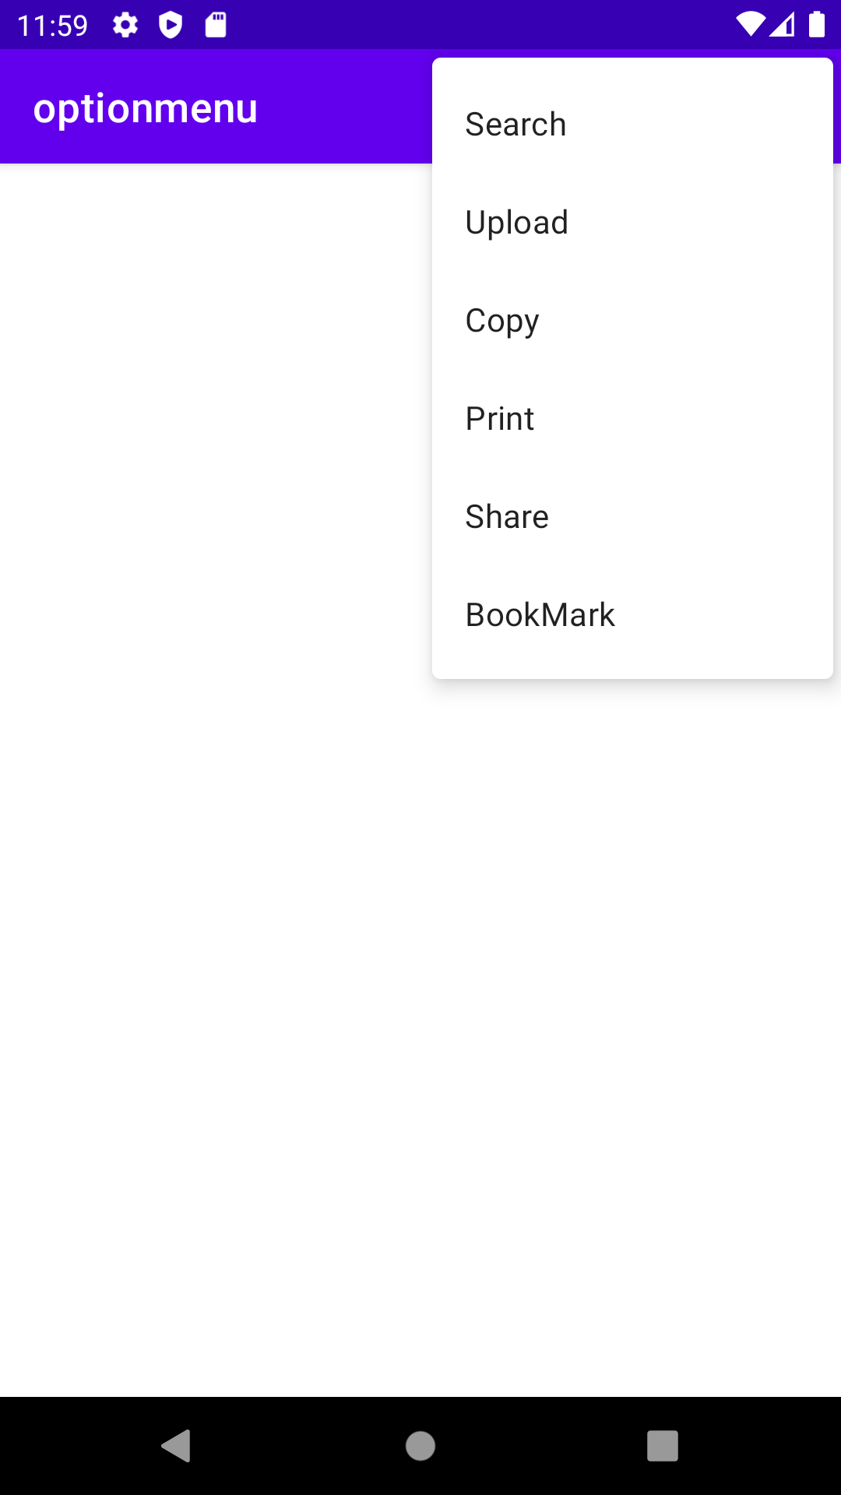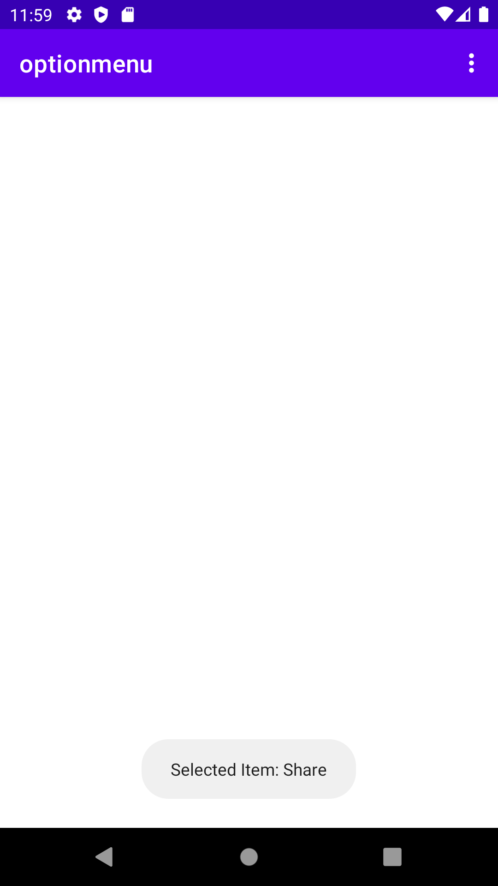

**WEEK-7**

**7) Aim: Create an android app to demonstrate option menu with handling listeners.**

**activitymain.xml**

<?xml version="1.0" encoding="utf-8"?>  
<androidx.constraintlayout.widget.ConstraintLayout  
 xmlns:android="http://schemas.android.com/apk/res/android"  
 xmlns:app="http://schemas.android.com/apk/res-auto"  
 xmlns:tools="http://schemas.android.com/tools"  
 android:layout_width="match_parent"  
 android:layout_height="match_parent"  
 tools:context=".MainActivity">  
</androidx.constraintlayout.widget.ConstraintLayout>

**MainActivity.java**

package com.vardhaman.optionmenu;

import androidx.appcompat.app.AppCompatActivity;

import android.os.Bundle;

import android.view.Menu;

import android.widget.Toast;

public class MainActivity extends AppCompatActivity {

@Override

protected void onCreate(Bundle savedInstanceState) {

super.onCreate(savedInstanceState);

setContentView(R.layout.activity_main); }

public boolean onCreateOptionsMenu(Menu menu) {

getMenuInflater().inflate(R.menu.list_menu, menu); return true }

@Override

public boolean onOptionsItemSelected(MenuItem item) {

Toast.makeText(this, "Selected Item: " +item.getTitle(), Toast.LENGTH_SHORT).show();

switch (item.getItemId()) {

case R.id.search_item: return true;

case R.id.upload_item: return true;

case R.id.copy_item: return true;

case R.id.print_item: return true;

case R.id.share_item:return true;

case R.id.bookmark_item: return true;

default: return super.onOptionsItemSelected(item);

} } }

**list_menu.xml**

<?xml version="1.0" encoding="utf-8"?>  
<menu xmlns:android="http://schemas.android.com/apk/res/android">  
 <item android:id="@+id/search_item android:title="Search" />  
 <item android:id="@+id/upload_item" android:title="Upload" />  
 <item android:id="@+id/copy_item"android:title="Copy" />  
 <item android:id="@+id/print_item"android:title="Print" />  
 <item android:id="@+id/share_item" android:title="Share" />

<item android:id="@+id/bookmark_item" android:title="BookMark" />  
</menu>

**OUTPUT :-**

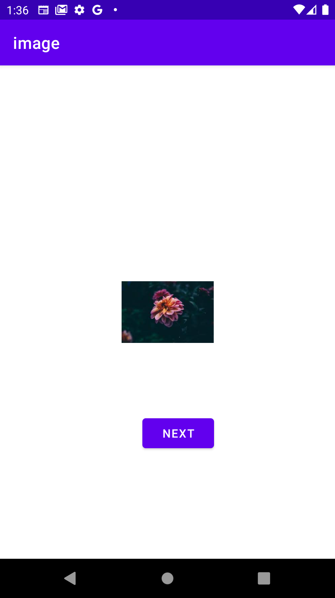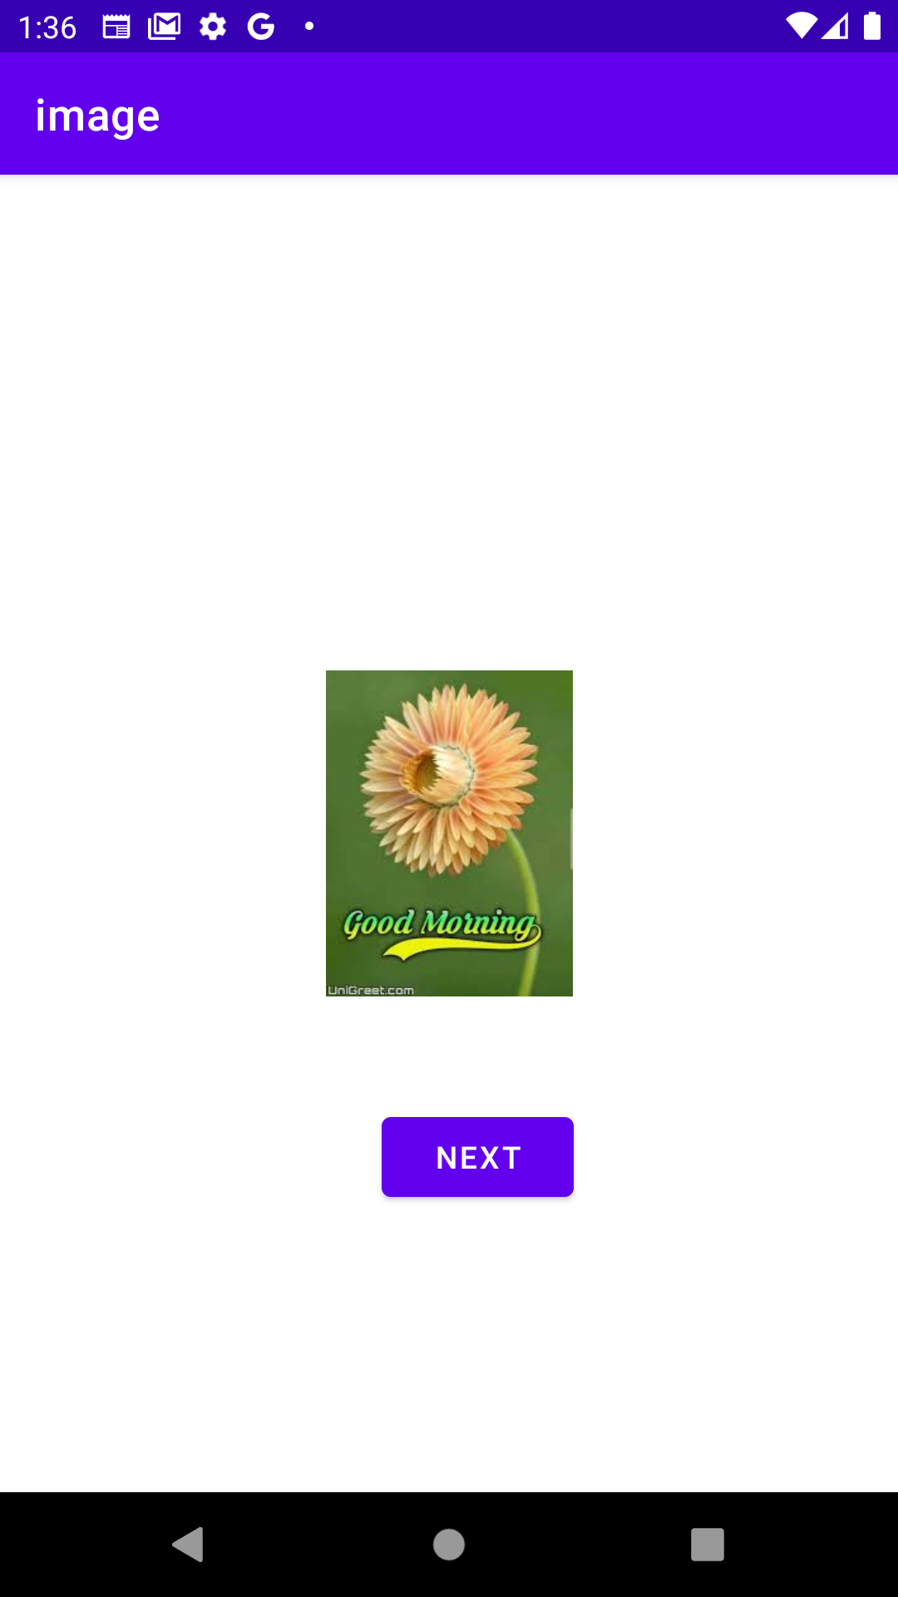

**WEEK-8**

**8) Aim: Create an android app to scroll list of images and display details of images (name, size etc)using ImageSwitcher control.**

**activity_main.xml**

<?xml version="1.0" encoding="utf-8"?>  
<androidx.constraintlayout.widget.ConstraintLayout xmlns:android="http://schemas.android.com/apk/res/android"  
 xmlns:app="http://schemas.android.com/apk/res-auto xmlns:tools="http://schemas.android.com/tools"  
 android:layout_width="match_parent"  
 android:layout_height="match_parent"  
 tools:context=".MainActivity">  
 <ImageSwitcher  
 android:id="@+id/imageSwitcher"  
 android:layout_width="113dp"  
 android:layout_height="182dp"/>  
 <Button  
 android:id="@+id/b"  
 android:layout_width="wrap_content"  
 android:layout_height="wrap_content"  
 android:text="next"  
</androidx.constraintlayout.widget.ConstraintLayout>

**MainActivity.java**

package com.vardhaman.image;  
import androidx.appcompat.app.AppCompatActivity;  
import android.os.Bundle;  
import android.view.View;  
import android.view.animation.Animation;  
import android.widget.Button;  
import android.widget.ImageSwitcher;  
import android.widget.ImageView;  
import android.widget.Toast;  
import android.widget.ViewSwitcher;  
public class MainActivity extends AppCompatActivity {  
 ImageSwitcher is;  
 Button b;  
 int imageSwitcherImages[]={R.drawable.download,R.drawable.image,R.drawable.one,R.drawable.two,R.drawable.three};  
 int switcherImageLength=imageSwitcherImages.length;  
 int counter=-1;  
 @Override  
 protected void onCreate(Bundle savedInstanceState) {  
 super.onCreate(savedInstanceState);  
 setContentView(R.layout.activity_main);  
 is=(ImageSwitcher)findViewById(R.id.imageSwitcher); b=(Button)findViewById(R.id.b);  
 is.setFactory(new ViewSwitcher.ViewFactory(){  
 @Override  
 public View makeView() {  
 ImageView switcherImageView=new ImageView(getApplicationContext());  
 switcherImageView.setScaleType(ImageView.ScaleType.FIT_CENTER);  
 switcherImageView.setImageResource(R.drawable.download);  
 return switcherImageView;  
 }});  
 Animation aout= AnimationUtils.loadAnimation(this, android.R.anim.slide_out_right);  
 Animation ain= AnimationUtils.loadAnimation(this, android.R.anim.slide_in_left);  
 is.setOutAnimation(aout);  
 is.setOutAnimation(ain);  
 b.setOnClickListener(new View.OnClickListener() {  
 @Override  
 public void onClick(View v) {counter++;  
 if(counter==switcherImageLength) {counter=0;  
 is.setImageResource(imageSwitcherImages[counter]);  
 Toast t= Toast.makeText(getApplicationContext(),"IMAGE", Toast.LENGTH_LONG);  
 t.show(); }  
 else{ is.setImageResource(imageSwitcherImages[counter]);  
 } }});}}

**OUTPUT :-**

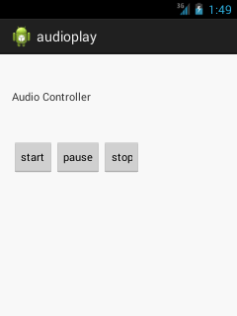

**WEEK-9**

**9a) Aim: Create an android app to demonstrate mediaplyer**

**activity_main.xml**

<RelativeLayout xmlns:androclass="http://schemas.android.com/apk/res/android"

xmlns:tools="http://schemas.android.com/tools"

android:layout_width="match_parent"

android:layout_height="match_parent"

tools:context=".MainActivity" >

<TextView

android:id="@+id/textView1"

android:layout_width="wrap_content"

android:layout_height="wrap_content"

android:layout_alignParentTop="true"

android:layout_marginTop="30dp"

android:text="Audio Controller" />

<Button

android:id="@+id/button1"

android:layout_width="wrap_content"android:layout_height="wrap_content"

android:layout_marginTop="48dp"

android:text="start" />

<Button

android:id="@+id/button2"

android:layout_width="wrap_content"

android:layout_height="wrap_content"

android:text="pause" />

<Button

android:id="@+id/button3"

android:layout_width="wrap_content"

android:layout_height="wrap_content"

android:text="stop" />

</RelativeLayout>

**MainActivity.java**

package com.example.audioplay;

import android.media.MediaPlayer;

import android.os.Bundle;

import android.app.Activity;

import android.view.Menu;

import android.view.View;

import android.view.View.OnClickListener;

import android.widget.Button;

public class MainActivity extends Activity {

Button start,pause,stop;

@Override

protected void onCreate(Bundle savedInstanceState) {

super.onCreate(savedInstanceState);

setContentView(R.layout.activity_main);

start=(Button)findViewById(R.id.button1);

pause=(Button)findViewById(R.id.button2);

stop=(Button)findViewById(R.id.button3);

//creating media player

final MediaPlayer mp=new MediaPlayer();

try{

mp.setDataSource(Environment.getExternalStorageDirectory().getPath()+"/Music/maine.mp3");

mp.prepare();

}catch(Exception e){e.printStackTrace();}

start.setOnClickListener(new OnClickListener() {

@Override

public void onClick(View v) {mp.start();}

});

pause.setOnClickListener(new OnClickListener() {

@Override

public void onClick(View v) {

mp.pause();}});

stop.setOnClickListener(new OnClickListener() {

@Override

public void onClick(View v) {mp.stop();

}});}}

**OUTPUT :-**

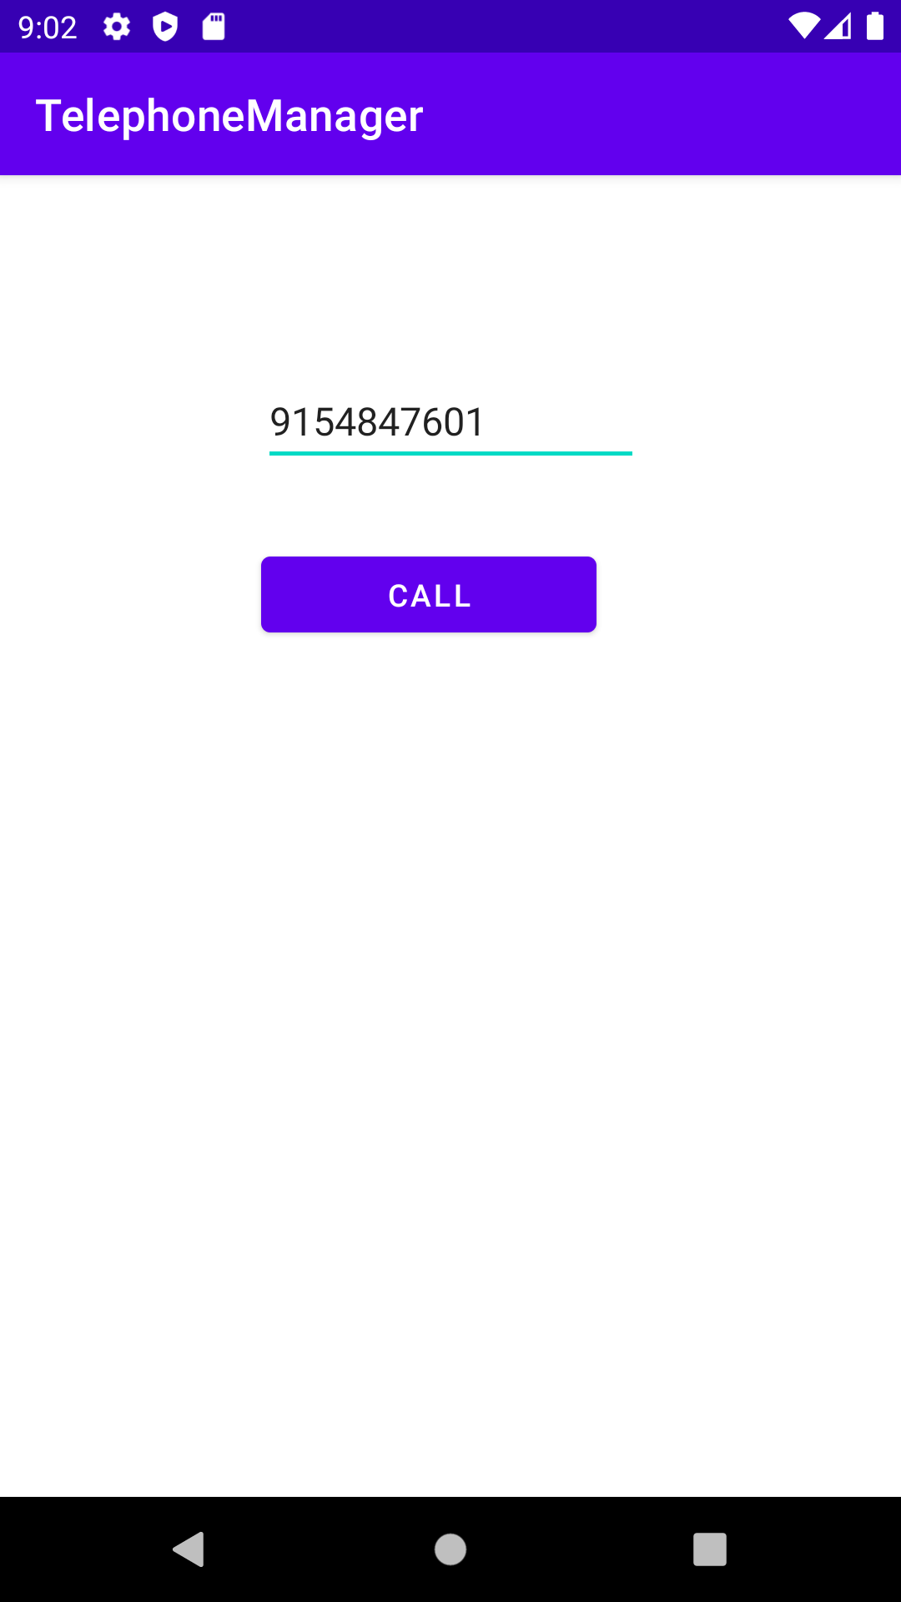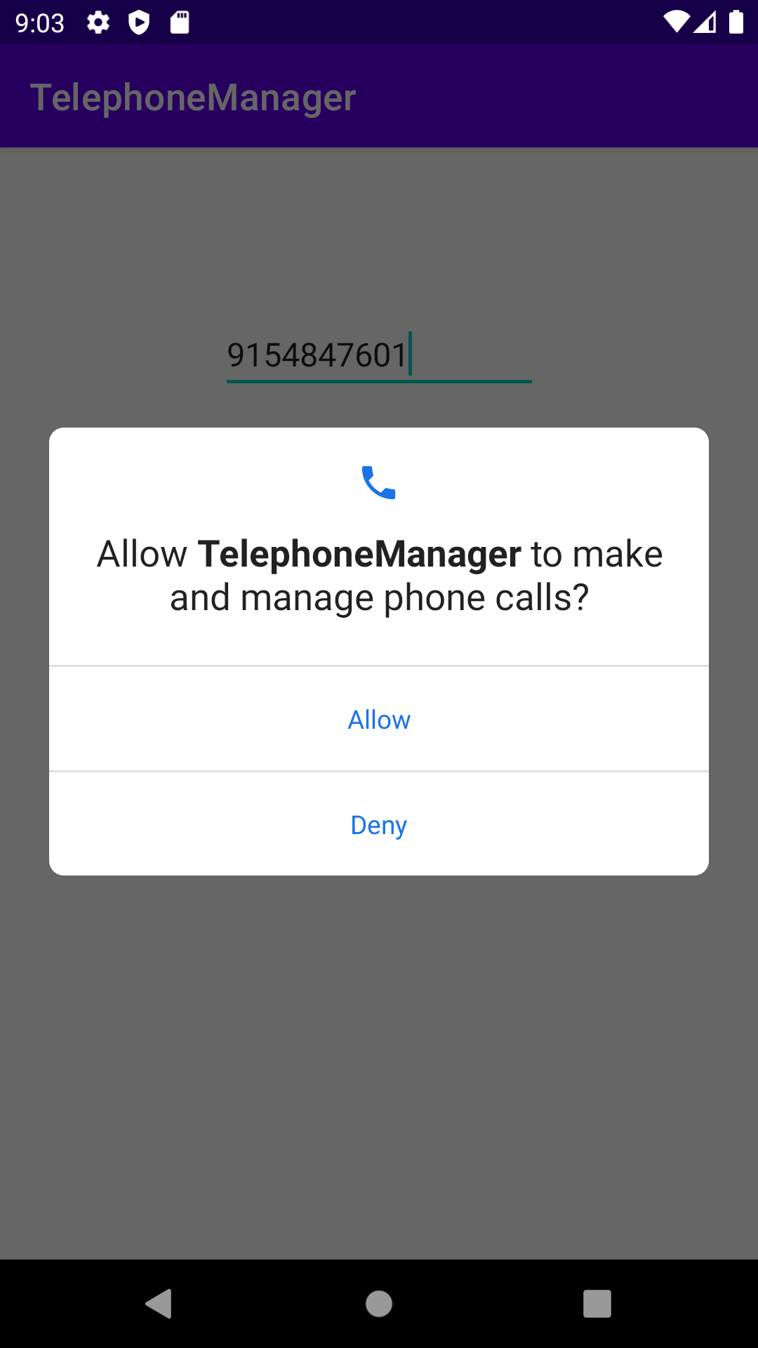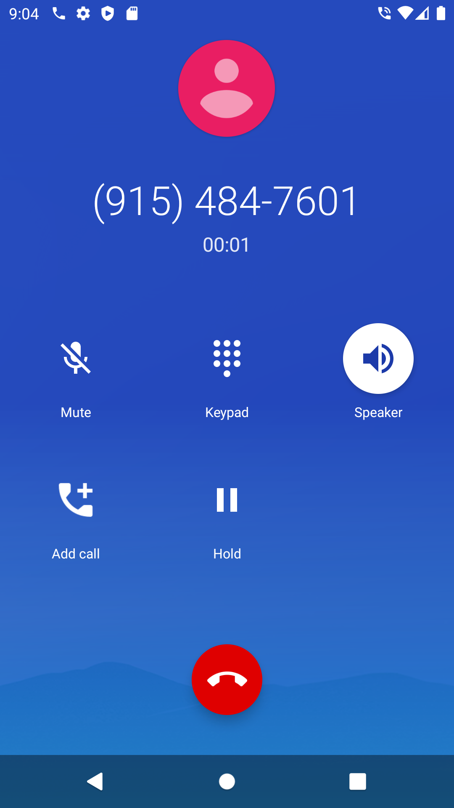

**9b) Aim: Create an android app to show details of phone contacts and implement calling, receiving**

**activity_main.xml**

*<?*xml version="1.0" encoding="utf-8"*?>*<androidx.constraintlayout.widget.ConstraintLayout  
 xmlns:android="http://schemas.android.com/apk/res/android"  
 xmlns:app="http://schemas.android.com/apk/res-auto"  
 xmlns:tools="http://schemas.android.com/tools"  
 android:layout_width="match_parent"  
 android:layout_height="match_parent"  
 tools:context=".MainActivity">  
 <EditText  
 android:id="@+id/et1"  
 android:layout_width="wrap_content"  
 android:layout_height="wrap_content"  
 android:hint="Enter Phone Number"/>  
 <Button  
 android:id="@+id/bt"  
 android:layout_width="153dp"  
 android:layout_height="46dp"  
 android:layout_weight="1"  
 android:text="Call"  
</androidx.constraintlayout.widget.ConstraintLayout>

**MainActivity.java**

package com.vardhaman.telephonemanager;  
import androidx.appcompat.app.AppCompatActivity;  
import android.content.Intent;  
import android.content.pm.PackageManager;  
import android.net.Uri;  
import android.os.Build;  
import android.os.Bundle;  
import android.view.View;  
import android.widget.Button;  
import android.widget.EditText;  
public class MainActivity extends AppCompatActivity {  
 Button b;EditText phno;  
 @Override  
 protected void onCreate(Bundle savedInstanceState) {  
 super.onCreate(savedInstanceState);  
 setContentView(R.layout.*activity_main*);  
 phno = (EditText) findViewById(R.id.*et1*);  
 b = (Button) findViewById(R.id.*bt*);  
 b.setOnClickListener(new View.OnClickListener() {  
 @Override  
 public void onClick(View v) {  
 callPhoneNumber(); }  
 }); }  
 public void requestPermissionsResult(int requestCode, String[] permissions, int[] grantResults) {  
 if (requestCode == 101) {  
 if (grantResults[0] == PackageManager.*PERMISSION_GRANTED*) {  
 callPhoneNumber();  
 } } }  
 public void callPhoneNumber() {  
 try {  
 if (Build.VERSION.*SDK_INT* > 22) {  
 if (ActivityCompat.*checkSelfPermission*(this, Manifest.permission.*CALL_PHONE*) != PackageManager.*PERMISSION_GRANTED*) {  
 ActivityCompat.*requestPermissions*(MainActivity.this, new String[]}

**manifest.xml**

*<?*xml version="1.0" encoding="utf-8"*?>*<manifest xmlns:android="http://schemas.android.com/apk/res/android"  
 package="com.vardhaman.telephonemanager">  
 <uses-permission android:name="android.permission.CALL_PHONE"></uses-permission>  
 <application  
 android:allowBackup="true"  
 android:icon="@mipmap/ic_launcher"  
 android:label="@string/app_name"  
 android:roundIcon="@mipmap/ic_launcher_round"  
 android:supportsRtl="true"  
 android:theme="@style/Theme.TelephoneManager">  
 <activity android:name=".MainActivity">  
 <intent-filter>  
 <action android:name="android.intent.action.MAIN" />  
 <category android:name="android.intent.category.LAUNCHER" />  
 </intent-filter></activi </application>

</manifest>

**OUTPUT :-**

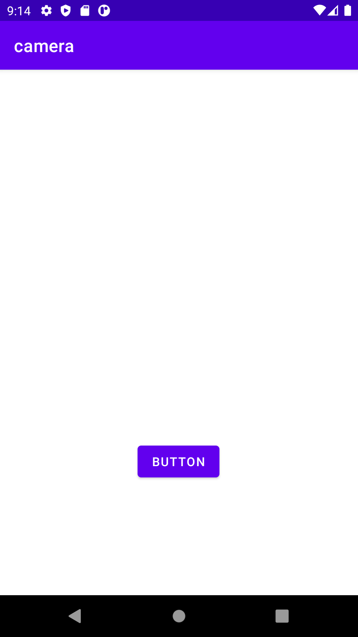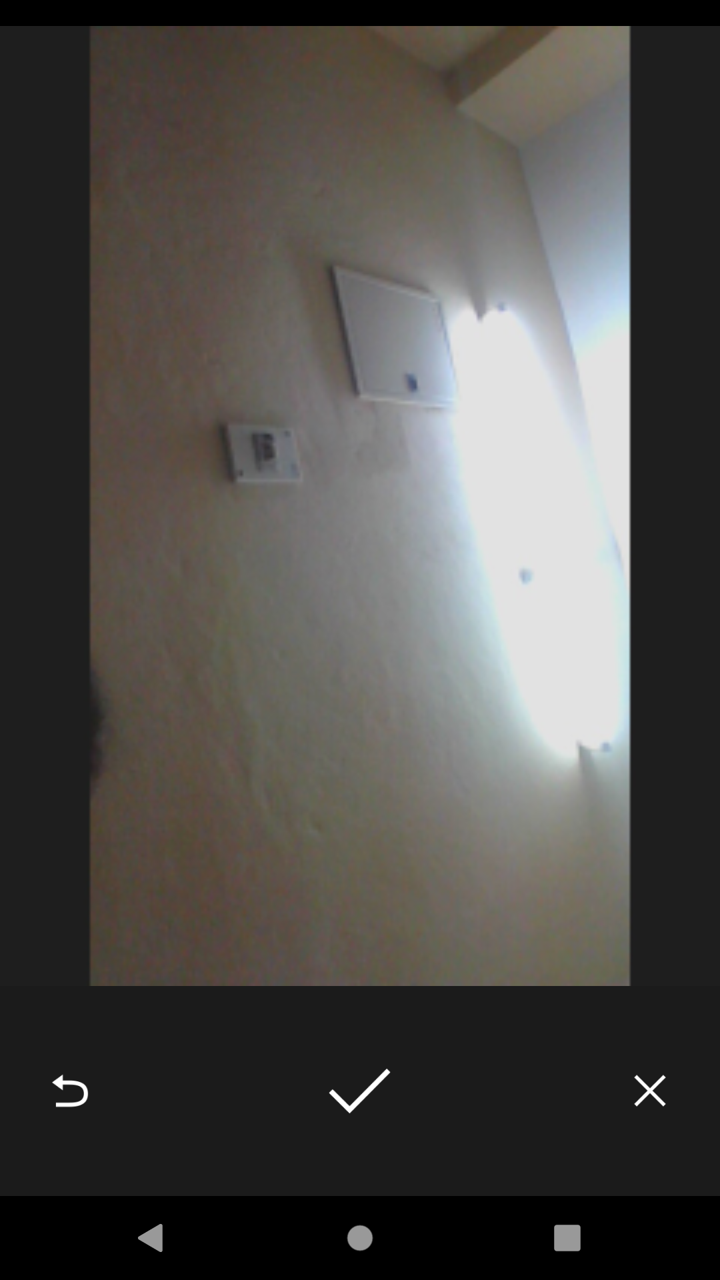

**WEEK-10**

**10) Aim: Create an android app to demonstrate camera.**

**activity_main.xml**

*<?*xml version="1.0" encoding="utf-8"*?>*  
<androidx.constraintlayout.widget.ConstraintLayout xmlns:android="http://schemas.android.com/apk/res/android"  
 xmlns:app="http://schemas.android.com/apk/res-auto"  
 xmlns:tools="http://schemas.android.com/tools"  
 android:layout_width="match_parent"  
 android:layout_height="match_parent"  
 tools:context=".MainActivity">  
 <Image View  
 android:id="@+id /imageView1"  
 android:layout_width="wrap_content"  
 android:layout_height="wrap_content"  
 tools:srcCompat="@tools:sample/avatars" />  
 <Button  
 android:id="@+id/button1"  
 android:layout_width="wrap_content"  
 android:layout_height="wrap_content"  
 android:text="Button"  
 app:layout_constraintVertical_bias="0.767" />  
</androidx.constraintlayout.widget.ConstraintLayout>

**MainActivity.java**

package com.vardhaman.camera;  
import androidx.appcompat.app.AppCompatActivity;  
import android.content.Intent;  
import android.graphics.Bitmap;  
import android.os.Bundle;  
import android.view.View;  
import android.widget.Button;  
import android.widget.ImageView;  
public class MainActivity extends AppCompatActivity {  
 private static final int *CAMERA_REQUEST* = 1888;  
 ImageView imageView;  
 @Override  
 protected void onCreate(Bundle savedInstanceState) {  
 super.onCreate(savedInstanceState);  
 setContentView(R.layout.*activity_main*);  
 imageView = (ImageView) this.findViewById(R.id.*imageView1*);  
 Button photoButton = (Button) this.findViewById(R.id.*button1*);  
 photoButton.setOnClickListener(new View.OnClickListener() {  
 @Override  
 public void onClick(View v) {  
 Intent cameraIntent = new Intent(android.provider.MediaStore.*ACTION_IMAGE_CAPTURE*);  
 startActivityForResult(cameraIntent, *CAMERA_REQUEST*);  
 }  
 });}  
 protected void OnActivityResult(int requestCode, int resultCode, Intent data) {  
 if (requestCode == *CAMERA_REQUEST*) {  
 Bitmap photo = (Bitmap) data.getExtras().get("data");  
 imageView.setImageBitmap(photo);

}}}

**OUTPUT :-**

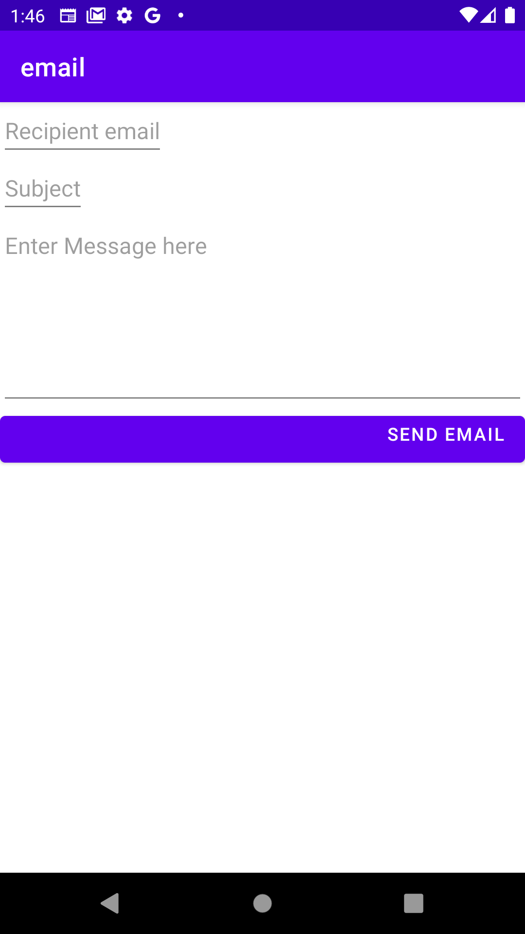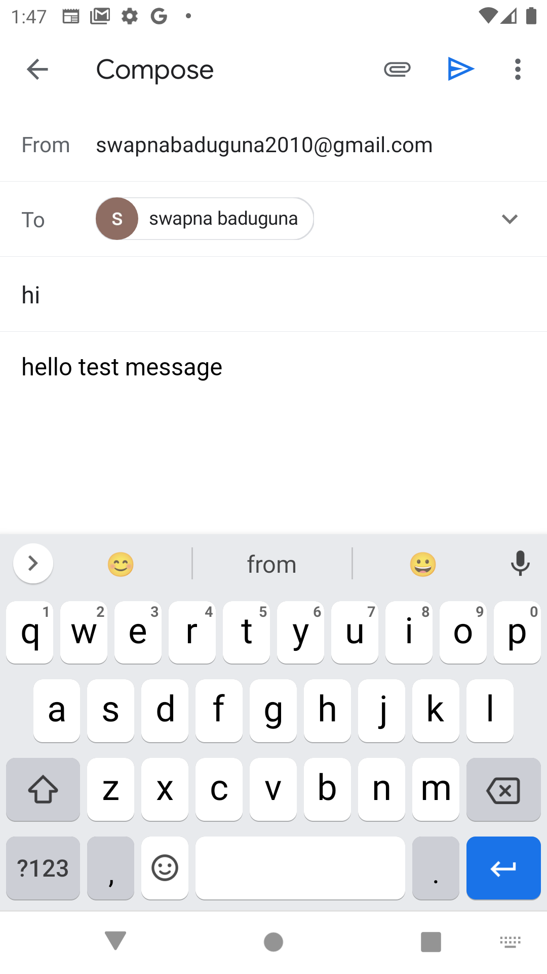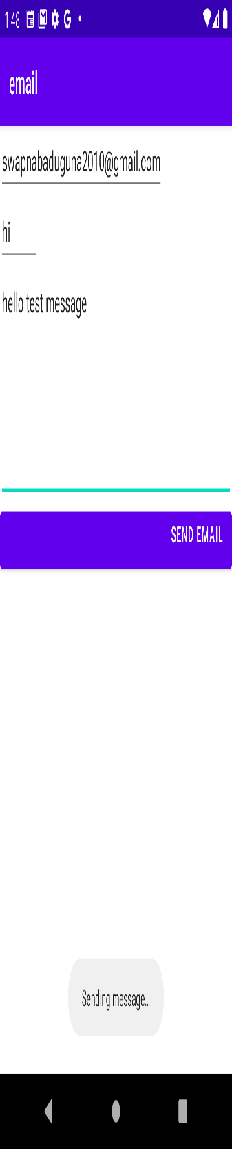

**WEEK-11**

**11a) Aim: Create an android app to demonstrate sending e-mail**

**activity_main.xml**

<?xml version="1.0" encoding="utf-8"?>

<LinearLayout

xmlns:android="http://schemas.android.com/apk/res/android"

xmlns:app="http://schemas.android.com/apk/res-auto"

xmlns:tools="http://schemas.android.com/tools"

android:layout_width="match_parent"

android:layout_height="match_parent"

android:orientation="vertical"

tools:context=".MainActivity">

<EditText

android:id="@+id/recipient"

android:layout_width="wrap_content"

android:layout_height="wrap_content"

android:inputType="textEmailAddress"

android:hint="Recipient email" />

<EditText

android:id="@+id/subject"

android:layout_width="wrap_content"

android:hint="Subject"

android:layout_height="wrap_content" />

<Button

android:id="@+id/button"

android:layout_width="match_parent"

android:layout_height="wrap_content"

android:gravity="end"

android:text="Send Email" />

</LinearLayout>

**MainActivity.java**

package com.vardhaman.email;

import androidx.appcompat.app.AppCompatActivity;

import android.content.Intent;

import android.net.Uri;

import android.os.Bundle;

import android.view.View;

import android.widget.Button;

import android.widget.EditText;

import android.widget.Toast;

public class MainActivity extends AppCompatActivity {

EditText editTextTo,editTextSubject,editTextMessage; Button send;

@Override

protected void onCreate(Bundle savedInstanceState) {

super.onCreate(savedInstanceState);

setContentView(R.layout.activity_main);

editTextTo=(EditText)findViewById(R.id.recipient); editTextSubject=(EditText)findViewById(R.id.subject);

editTextMessage=(EditText)findViewById(R.id.Message);send=(Button)findViewById(R.id.button);

send.setOnClickListener(new View.OnClickListener() {

@Override

public void onClick(View v) {

String re=editTextTo.getText().toString().trim();

String su=editTextSubject.getText().toString().trim();

String me=editTextMessage.getText().toString().trim();

sendEmail(re,su,me);

}

});}

private void sendEmail(String re, String su, String me) {

Intent i=new Intent(Intent.ACTION_SEND);

i.setData(Uri.parse("Mail to"));

i.setType("text/plain");

i.putExtra(Intent.EXTRA_EMAIL,new String[]{re});

i.putExtra(Intent.EXTRA_SUBJECT,su);

i.putExtra(Intent.EXTRA_TEXT,me);

try{

startActivity(Intent.createChooser(i,"choose an email client"));

}

catch(Exception e){

Toast.makeText(this,e.getMessage(),Toast.LENGTH_SHORT).show();

}}

**OUTPUT :-**

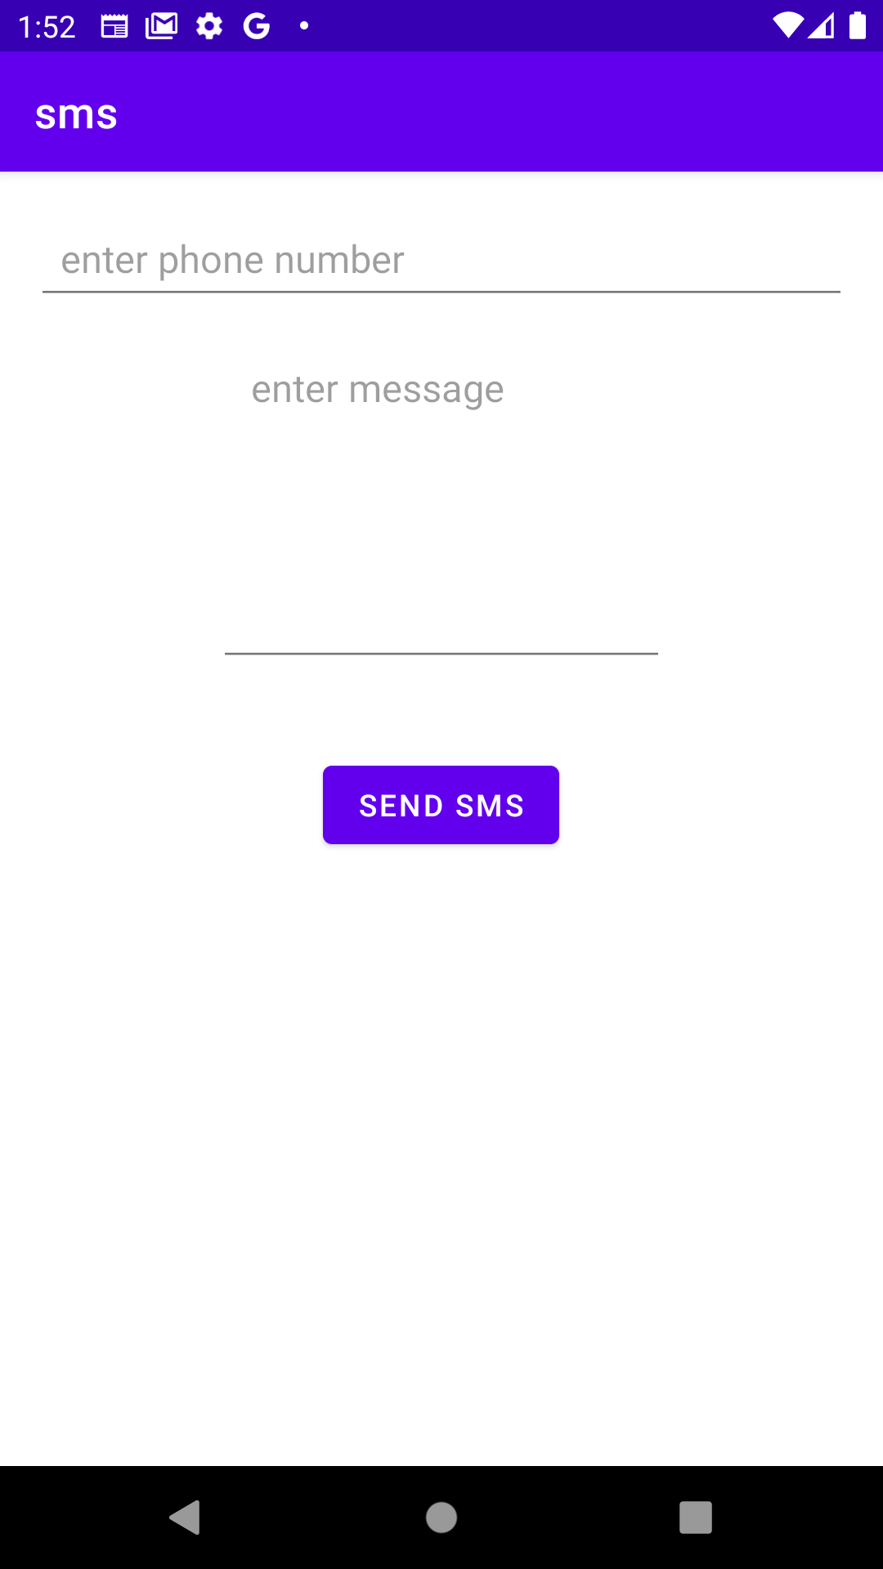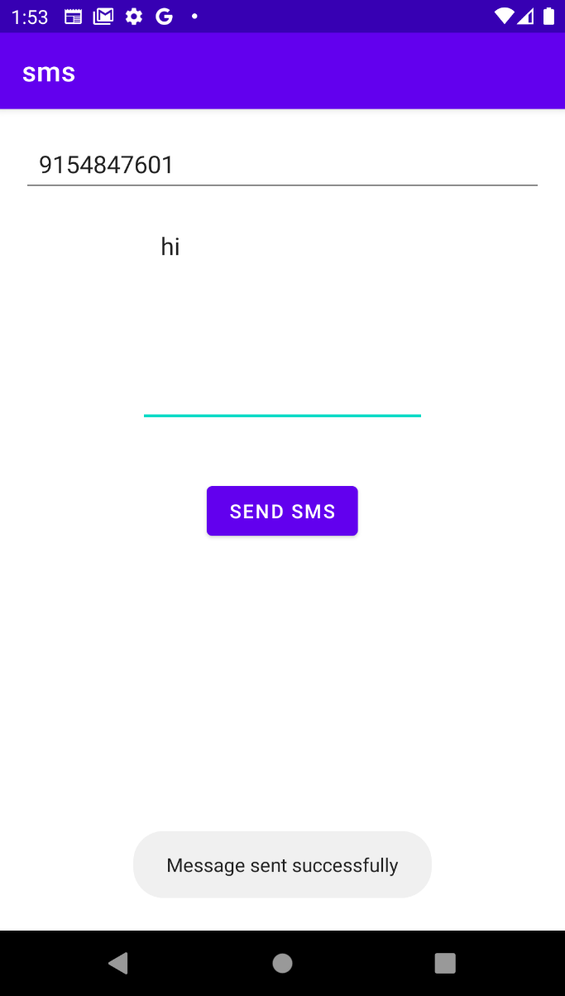

**11b) Aim: Create an android app to demonstrate sending SMS**

**activity_main.xml**

<RelativeLayout xmlns:androclass="http://schemas.android.com/apk/res/android"

xmlns:tools="http://schemas.android.com/tools"

android:layout_width="match_parent"

android:layout_height="match_parent"

tools:context=".MainActivity" >

<EditText

android:id="@+id/editText1"

android:layout_width="wrap_content"

android:layout_height="wrap_content"

android:ems="10" />

<EditText

android:id="@+id/editText2"

android:layout_width="wrap_content"

android:layout_height="wrap_content"

android:ems="10"

android:inputType="textMultiLine" />

<TextView

android:id="@+id/textView1"android:layout_width="wrap_content"

android:layout_height="wrap_content"

android:text="Mobile No:" />

<TextView

android:id="@+id/textView2"

android:layout_width="wrap_content"

android:layout_height="wrap_content"

android:text="Message:" />

<Button

android:id="@+id/button1"

android:layout_width="wrap_content"

android:layout_height="wrap_content"

android:text="Send SMS" />

</RelativeLayout>

**Android-Manifest.xml**

<uses-permission android:name="android.permission.SEND_SMS"/>

**MainActivity.java**

package com.example.sendsms;

import android.os.Bundle;

import android.app.Activity;

import android.app.PendingIntent;

import android.content.Intent;

import android.telephony.SmsManager;

import android.view.Menu;

import android.widget.Button;

import android.widget.EditText;

import android.widget.Toast;

public class MainActivity extends Activity {

EditText mobileno,message;Button sendsms;

@Override

protected void onCreate(Bundle savedInstanceState) {

super.onCreate(savedInstanceState);

setContentView(R.layout.activity_main);

mobileno=(EditText)findViewById(R.id.editText1);

message=(EditText)findViewById(R.id.editText2);

sendsms=(Button)findViewById(R.id.button1);

sendsms.setOnClickListener(new OnClickListener() {

@Override

public void onClick(View arg0) {

String no=mobileno.getText().toString();

String msg=message.getText().toString();

Intent intent=new Intent(getApplicationContext(),MainActivity.class);

PendingIntent pi=PendingIntent.getActivity(getApplicationContext(), 0, intent,0);

SmsManager sms=SmsManager.getDefault();

sms.sendTextMessage(no, null, msg, pi,null);

Toast.makeText(getApplicationContext(), "Message Sent successfully!",

Toast.LENGTH_LONG).show();

} }); }

@Override

public boolean onCreateOptionsMenu(Menu menu) {

getMenuInflater().inflate(R.menu.activity_main, menu);return true;

}}

**OUTPUT :-**

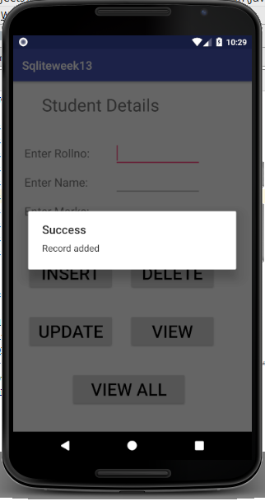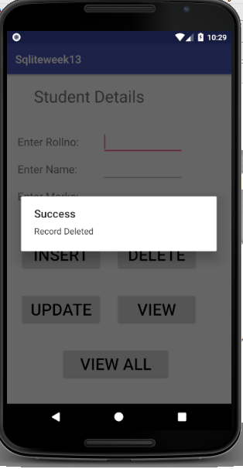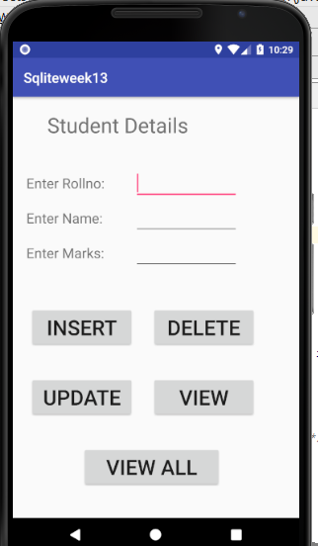

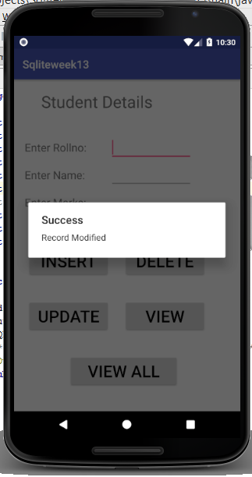

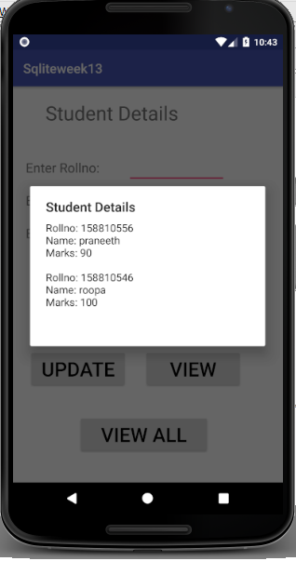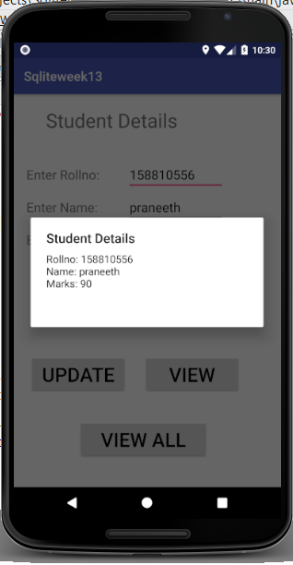

**WEEK-12**

**12) Aim: Create an android app to store details of students in SQLite and display the details perform insert,update, delete operations on student database**

**activity_main.xml**

<AbsoluteLayoutxmlns:android="http://schemas.android.com/apk/res/android"

android:layout_width="match_parent"

android:layout_height="match_parent">

<TextView

android:layout_width="wrap_content"

android:layout_height="wrap_content"

android:text="Student Details"

android:textSize="30sp" />

<EditText

android:id="@+id/Rollno"

android:layout_width="150dp"

android:layout_height="wrap_content"

android:inputType="number"

android:textSize="20sp" />

<TextView

android:layout_width="wrap_content"

android:layout_height="wrap_content"

android:text="Enter Name:"

android:textSize="20sp" /><EditText

<TextView

android:layout_width="wrap_content"

android:layout_height="wrap_content"

android:text="Enter Marks:"

android:textSize="20sp" />

<EditText

android:id="@+id/Marks"

android:layout_width="150dp"

android:layout_height="wrap_content"

android:inputType="number"

android:textSize="20sp" />

<Button

android:id="@+id/Insert"

android:layout_width="150dp"

android:layout_height="wrap_content"

android:text="Insert"

android:textSize="30dp" />

<Button

android:id="@+id/Delete"

android:layout_width="150dp"

android:layout_height="wrap_content"

android:text="Delete"

android:textSize="30dp" /><Button

android:id="@+id/Update"

android:layout_width="150dp"

android:layout_height="wrap_content"

android:text="Update"

android:textSize="30dp" />

<Button

android:id="@+id/View"

android:layout_width="150dp"

android:layout_height="wrap_content"

android:text="View"

android:textSize="30dp" />

<Button

android:id="@+id/ViewAll"

android:layout_width="200dp"

android:layout_height="wrap_content"

android:text="View All"

android:textSize="30dp" />

</AbsoluteLayout>

**MainActivity.java**

import android.support.v7.app.AlertDialog;

import android.support.v7.app.AppCompatActivity;

importandroid.os.Bundle;

importandroid.content.Context;

importandroid.os.Bundle;

importandroid.view.View;

importandroid.widget.Button;

importandroid.widget.EditText;

public class MainActivity extends AppCompatActivity implements android.view.View.OnClickListener {EditTextRollno,Name,Marks;

Button Insert,Delete,Update,View,ViewAll;

SQLiteDatabasedb;

@Override

public void onCreate(Bundle savedInstanceState)

{

super.onCreate(savedInstanceState);

setContentView(R.layout.activity_main);

Rollno=(EditText)findViewById(R.id.Rollno);

Name=(EditText)findViewById(R.id.Name);

Marks=(EditText)findViewById(R.id.Marks);

Insert=(Button)findViewById(R.id.Insert);

Delete=(Button)findViewById(R.id.Delete);

Update=(Button)findViewById(R.id.Update);

View=(Button)findViewById(R.id.View);

ViewAll=(Button)findViewById(R.id.ViewAll);

Insert.setOnClickListener(this);

Delete.setOnClickListener(this);

Update.setOnClickListener(this);

View.setOnClickListener(this);

ViewAll.setOnClickListener(this);

db=openOrCreateDatabase("StudentDB", Context.MODE_PRIVATE, null);

db.execSQL("CREATE TABLE IF NOT EXISTS student(rollnoVARCHAR,nameVARCHAR,marks

VARCHAR);");

}

public void onClick(View view)

{

if(view==Insert)

{

if(Rollno.getText().toString().trim().length()==0||

Name.getText().toString().trim().length()==0||

Marks.getText().toString().trim().length()==0)

{

showMessage("Error", "Please enter all values");

return;

}

db.execSQL("INSERT INTO student VALUES('"+Rollno.getText()+"','"+Name.getText()+"','"+Marks.getText()+"');");

showMessage("Success", "Record added");

clearText();

}

if(view==Delete)

{

if(Rollno.getText().toString().trim().length()==0)

{

showMessage("Error", "Please enter Rollno");

return;

}

Cursor c=db.rawQuery("SELECT * FROM student WHERE rollno='"+Rollno.getText()+"'", null);

if(c.moveToFirst())

{

db.execSQL("DELETE FROM student WHERE rollno='"+Rollno.getText()+"'");

showMessage("Success", "Record Deleted");

}

else

{

showMessage("Error", "Invalid Rollno");

}

clearText();

}

if(view==Update)

{

// Checking for empty roll number

if(Rollno.getText().toString().trim().length()==0)

{

showMessage("Error", "Please enter Rollno");

return;

}

Cursor c=db.rawQuery("SELECT * FROM student WHERE rollno='"+Rollno.getText()+"'", null);

if(c.moveToFirst()) {

db.execSQL("UPDATE student SET name='" + Name.getText() + "',marks='" + Marks.getText() +

"' WHERE rollno='"+Rollno.getText()+"'");

showMessage("Success", "Record Modified");

}

else {

showMessage("Error", "Invalid Rollno");

}

clearText();}

if(view==View)

{

// Checking for empty roll number

if(Rollno.getText().toString().trim().length()==0)

{

showMessage("Error", "Please enter Rollno");

return;

}

Cursor c=db.rawQuery("SELECT * FROM student WHERE rollno='"+Rollno.getText()+"'", null);

if(c.moveToFirst())

{

Name.setText(c.getString(1));

Marks.setText(c.getString(2));

}

else

{

showMessage("Error", "Invalid Rollno");

clearText();

}

}

if(view==ViewAll)

{

Cursor c=db.rawQuery("SELECT * FROM student", null);

if(c.getCount()==0)

{

showMessage("Error", "No records found");

return;

}

StringBuffer buffer=new StringBuffer();

while(c.moveToNext())

{

buffer.append("Rollno: "+c.getString(0)+"\n");

buffer.append("Name: "+c.getString(1)+"\n");

buffer.append("Marks: "+c.getString(2)+"\n\n");

}

showMessage("Student Details", buffer.toString());

}

}

public void showMessage(String title,String message)

{

AlertDialog.Builder builder=new AlertDialog.Builder(this);builder.setCancelable(true);

builder.setTitle(title);

builder.setMessage(message);

builder.show();

}

public void clearText()

{

Rollno.setText("");

Name.setText("");

Marks.setText("");

Rollno.requestFocus();

}

}